Milestone 2
Create UI Policy Action – Urgency

Objective
Configure a UI Policy Action for the Urgency field under the High Impact Control UI Policy.

Activity 1 – Configure the Urgency Field
- Open the High Impact Control UI Policy.
- Scroll to the UI Policy Actions related list.
- Click New to create a UI Policy Action.
- Select the Urgency field.
- Set Read-only to true.
- Leave Visible unchanged.
- Click Submit to save the UI Policy Action.

Configuration
- Field name: Urgency
- Read-only: true
- Visible: unchanged
- Condition inherited from High Impact Control: Impact = High

Verification
- Open an Incident record.
- Set Impact to High.
- Check that the Urgency field becomes read-only.
- Change Impact to another value and confirm that the field can revert when the condition is false.

Expected Result
When Impact is High, the Urgency field is displayed but cannot be changed by the user.
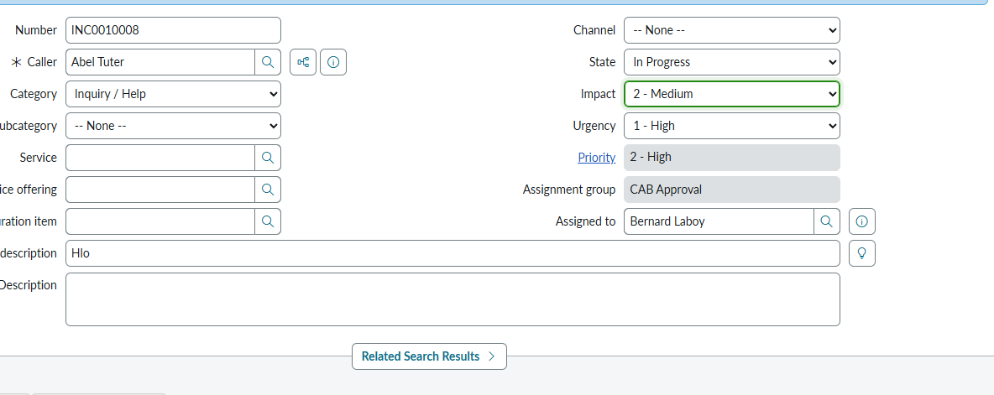
Place the screenshot showing the Urgency UI Policy Action here in the final documentation if desired.

